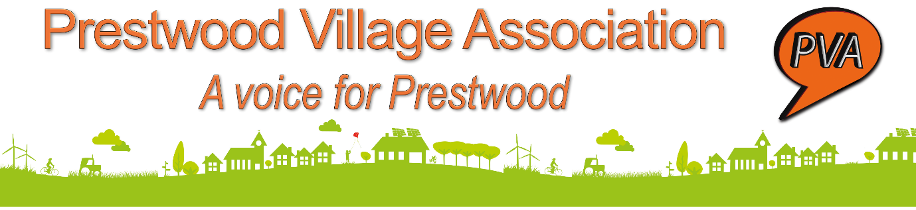

Draft Annual General Meeting Minutes
Tuesday 26 April 2022at 7.00pm via Zoom

Present:PVA Committee members – John Cadman, Graham Cross, Helen Francis, Simon Laurie, Paul Mes, Katy Nex, Colin Veysey, Mark Wingrove, Sue Wingrove. Invited speakers - Christopher Black, GMPRG Chair;Catherine Bunting, Lesley Cook, Robert Gibson, Peter Martin, Bucks Councillor;Dave Rollins, Youth Café; York Woodford-Smith, 5 on a Bike; Thomas Tyrrell.

Attendees: Margaret Ashwell, Miranda Aylott, Sylvia Bennett, Sue Brasted, Mary Cadman, Jenny Cassidy,Liz Charleston, MCB Co-ordinator, Bucks Council;Mandy Cotton, Sue Daniel, Diana Dove, Carole Eaden, Margaret Earnshaw, Liz Exell, John Gladwin, Lorraine Green, Harriet Griffin, Mimi Harker, Bucks Councillor; Mike Etkind, Leslie Harris, Jeanette Hedley, Deiniol Heywood, Rector of Holy Trinity Prestwood; Monica Hildred, Trevor Howes, Anita Irwin, Beryl & Mervyn Jones, James Leslau, Geoff Lewis, Karine Lipinski, Ivan Lovegrove, Lynda Marlow, Val Marshall, Ali Martin, Helen Matthews, Fiona McVeigh, Gill Medford, Lesley Mes, Susan Osborne, Karen Pither, Patricia Presland, Margaret Preston, Joe Privett, Vanessa Rickett, Sandra Robb, Barbara Rowett, David Ryan, Alison Semmens, Peter Singleton, Gillian Smith, Jenny Smith, Tim Stevenson, Graeme Summers, Christine Taylor, Alice Vranch, Geoff Walker, Heather Wallace, Bucks Councillor; Philippa Wallin, John & Mary Wiles, Lyn & Jane Williams, Alison Wolfreys, Chris Worsey, Helen Wright, Sadie Wright, Steve Yates.
Apologies :Wendy Buckley, Paul Egan, Judith Gibson, Vanessa Martin, PS Darren Walsh, Thames Valley Police.
John Cadman, PVA Committee member, welcomed everyone to the Zoom eventand indicated that the previous year’s draft minutes together with the year-end accounts had been circulated to all attending, in advance.
1,Minutes of the previous AGM (27 April 2021) – Adoption Proposed: John Cadman. Seconded: Lesley Cook. The minutes of the 2021 meeting were approved via a majority show of hands. There were no matters arising.
2.Treasurer's Report - The accounts for year ended 31 March 2022 were formally received and adopted by a majority show of hands, together with a vote of thanks to Lyn Williams for examining the accounts. Approval Proposed by Robert Gibson, Seconded: John Gladwin. Accounts were approved via a majority show of hands.
3.Election of Committee Members–John Cadman updated the meeting that Barbara Rowett retired from the committee in January 2022 but is continuing to help Helen Francis with the administration of the PVA face book group. Katy Nex took over as Treasurer from Simon Laurie during the year. Otherwise, the committee remained unchanged.
Although not proposing to change PVA’s constitution, the committee has pro-tem moved to taking it in turns to provide a “rotating” chair and minute-taking secretary from one bi-monthly meeting to the next as John Cadman, relinquished the Chair, having held it for the previous four years.
The following therefore offered themselves for re-election as committee members: John Cadman, Graham Cross, Helen Francis, Simon Laurie, Paul Mes, Katy Nex, Mark Wingrove, Sue Wingrove and Colin Veysey. Karine Lipinski kindly agreed to propose with Tim Stevenson seconding so that all may be re-elected enbloc. Approved via a show of hands.
Unfortunately, no nominations were received for additional members of the PVA team for consideration by 18 April, but if anyone is interested in joining the management team, please let us know via the usual contact us route via the website or leave a message in Chat tonight. We have room for 4 more volunteers and would especially welcome people willing to learn or are au fait with Word Press websites and Facebook administration or contributing to being the eyes and ears of the village.
John Cadman expressed PVA’s sincere thanks to Richard and Karen Burden and Roger Almond who, for the past few years, have been very diligent and enthusiastic editors of our news items and TVP posts respectively. They have been a great help. They have decided to stand down so PVA would welcome a new pair of hands to help create the posts and Newsletter on the website. It’s not difficult and it would help you get involved in what is going on locally. Please consider joining us.
There being no questions, this ended the formal business of the AGM.
John Cadman thanked Barbara Rowett for her contribution to PVA over the last 10 years. To show their appreciation, the committee gave her some plants for her garden.
-------------------------------------------------------------------------------------------------------------------------------------------
The social programme followed with the theme being Prestwood Moving Forward. Simon Laurie set the scene with presentations from Peter Martin, Bucks Councillor & Chair of the Missendens Community Board speaking on Prestwood’s Voice – Prestwood’s Choice; Christopher Black, Chair of Great Missenden & Prestwood Revitalisation Group, on The Challenge of Community Conversation,and Colin Veysey & Dave Rollins on the Youth Needs Survey.
The final session, introduced by Paul Mes, consisted of Lesley Cook explaining the workings of the Parish Council, Catherine Bunting on the Prestwood Climate & Repair cafes and the local litter picking events, videos from local businesses, Thomas Tyrrell, 5 on a Bike and our local Post Office, and Robert Gibson on linking up with our Local Community Police, including Community Speed Watch update.
Many thanks to all speakers and everyone who helped put together the event.
280422/BR

